Linear Regression

Linear Regression is a machine learning algorithm based on supervised learning. It performs a regression task. Regression models a target prediction value based on independent variables. It is mostly used for finding out the relationship between variables and forecasting. Different regression models differ based on – the kind of relationship between dependent and independent variables they are considering, and the number of independent variables getting used.

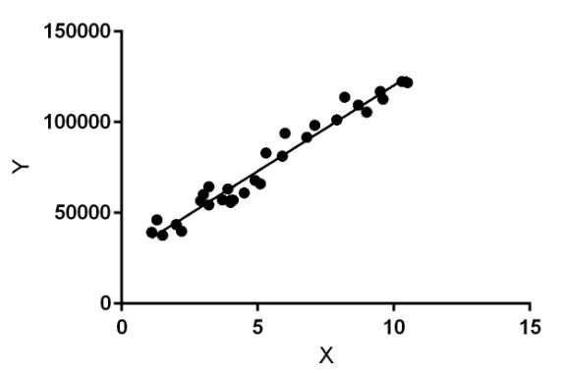

In statistics, linear regression is a linear approach for modelling the relationship between a scalar response and one or more explanatory variables (also known as dependent and independent variables). The case of one explanatory variable is called simple linear regression; for more than one, the process is called multiple linear regressions. This term is distinct from multivariate linear regression, where multiple correlated dependent variables are predicted, rather than a single scalar variable.

Linear regression models are often fitted using the least squares approach, but they may also be fitted in other ways, such as by minimizing the "lack of fit" in some other norm (as with least absolute deviations regression), or by minimizing a penalized version of the least squares cost function as in ridge regression (L2-norm penalty) and lasso (L1-norm penalty). Conversely, the least squares approach can be used to fit models that are not linear models. Thus, although the terms "least squares" and "linear model" are closely linked, they are not synonymous.

A fitted linear regression model can be used to identify the relationship between a single predictor variable xj and the response variable y when all the other predictor variables in the model are "held fixed". Specifically, the interpretation of βj is the expected change in y for a one-unit change in xj when the other covariates are held fixed—that is, the expected value of the partial derivative of y with respect to xj. This is sometimes called the unique effect of xj on y. In contrast, the marginal effect of xj on y can be assessed using a correlation coefficient or simple linear regression model relating only xj to y; this effect is the total derivative of y with respect to xj.

Care must be taken when interpreting regression results, as some of the regressors may not allow for marginal changes (such as dummy variables, or the intercept term), while others cannot be held fixed (recall the example from the introduction: it would be impossible to "hold ti fixed" and at the same time change the value of ti2).



here T denotes the transpose, so that xiTβ is the inner product between vectors xi and β. Often these n equations are stacked together and written in matrix notation as



Where,

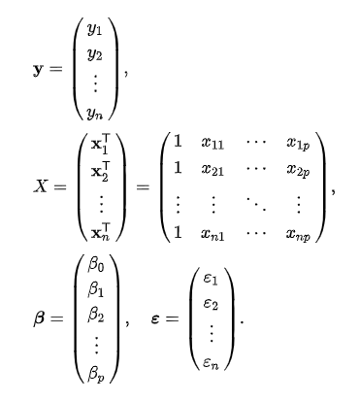

**Simple and multiple linear regressions:**

Example of simple linear regression, which has one independent variable

The very simplest case of a single scalar predictor variable x and a single scalar response variable y is known as simple linear regression. The extension to multiple and/or vector-valued predictor variables (denoted with a capital X) is known as multiple linear regression, also known as multivariable linear regression (not to be confused with multivariate linear regression ).

Multiple linear regressions is a generalization of simple linear regression to the case of more than one independent variable, and a special case of general linear models, restricted to one dependent variable.

Learning a linear regression model means estimating the values of the coefficients used in the representation with the data that we have available.

In this section we will take a brief look at four techniques to prepare a linear regression model. This is not enough information to implement them from scratch, but enough to get a flavor of the computation and trade-offs involved.

**Techniques**

There are many more techniques because the model is so well studied. Take note of Ordinary Least Squares because it is the most common method used in general. Also take note of Gradient Descent as it is the most common technique taught in machine learning classes.

1. Simple Linear Regression

With simple linear regression when we have a single input, we can use statistics to estimate the coefficients.

This requires that you calculate statistical properties from the data such as means, standard deviations, correlations and covariance. All of the data must be available to traverse and calculate statistics.

This is fun as an exercise in excel, but not really useful in practice.

2. Ordinary Least Squares

When we have more than one input we can use Ordinary Least Squares to estimate the values of the coefficients.

The Ordinary Least Squares procedure seeks to minimize the sum of the squared residuals. This means that given a regression line through the data we calculate the distance from each data point to the regression line, square it, and sum all of the squared errors together. This is the quantity that ordinary least squares seeks to minimize.

This approach treats the data as a matrix and uses linear algebra operations to estimate the optimal values for the coefficients. It means that all of the data must be available and you must have enough memory to fit the data and perform matrix operations.

It is unusual to implement the Ordinary Least Squares procedure yourself unless as an exercise in linear algebra. It is more likely that you will call a procedure in a linear algebra library. This procedure is very fast to calculate.

3. Gradient Descent

When there are one or more inputs you can use a process of optimizing the values of the coefficients by iteratively minimizing the error of the model on your training data.

This operation is called Gradient Descent and works by starting with random values for each coefficient. The sum of the squared errors are calculated for each pair of input and output values. A learning rate is used as a scale factor and the coefficients are updated in the direction towards minimizing the error. The process is repeated until a minimum sum squared error is achieved or no further improvement is possible.

When using this method, you must select a learning rate (alpha) parameter that determines the size of the improvement step to take on each iteration of the procedure.

Gradient descent is often taught using a linear regression model because it is relatively straightforward to understand. In practice, it is useful when you have a very large dataset either in the number of rows or the number of columns that may not fit into memory.

4. Regularization

There are extensions of the training of the linear model called regularization methods. These seek to both minimize the sum of the squared error of the model on the training data (using ordinary least squares) but also to reduce the complexity of the model (like the number or absolute size of the sum of all coefficients in the model).

Two popular examples of regularization procedures for linear regression are:

Lasso Regression: where Ordinary Least Squares is modified to also minimize the absolute sum of the coefficients (called L1 regularization).

Ridge Regression: where Ordinary Least Squares is modified to also minimize the squared absolute sum of the coefficients (called L2 regularization).

These methods are effective to use when there is collinearity in your input values and ordinary least squares would overfit the training data.

Now that you know some techniques to learn the coefficients in a linear regression model, let’s look at how we can use a model to make predictions on new data.

**Preparing Data For Linear Regression:**

Linear regression is been studied at great length, and there is a lot of literature on how your data must be structured to make best use of the model.

As such, there is a lot of sophistication when talking about these requirements and expectations which can be intimidating. In practice, you can uses these rules more as rules of thumb when using Ordinary Least Squares Regression, the most common implementation of linear regression.

Try different preparations of your data using these heuristics and see what works best for your problem.

Linear Assumption. Linear regression assumes that the relationship between your input and output is linear. It does not support anything else. This may be obvious, but it is good to remember when you have a lot of attributes. You may need to transform data to make the relationship linear (e.g. log transform for an exponential relationship).

Remove Noise. Linear regression assumes that your input and output variables are not noisy. Consider using data cleaning operations that let you better expose and clarify the signal in your data. This is most important for the output variable and you want to remove outliers in the output variable (y) if possible.

Remove Collinearity. Linear regression will over-fit your data when you have highly correlated input variables. Consider calculating pairwise correlations for your input data and removing the most correlated.

Gaussian Distributions. Linear regression will make more reliable predictions if your input and output variables have a Gaussian distribution. You may get some benefit using transforms (e.g. log or BoxCox) on you variables to make their distribution more Gaussian looking.

Rescale Inputs: Linear regression will often make more reliable predictions if you rescale input variables using standardization or normalization.